**Information Retrieval(IR)**

**1. Problem Statement**: User will type Questions/Queries, system has to retrieve related answers to the questions and related paragraphs/sentences with the highlighted answers where the answer was found. Below image gives clear idea.

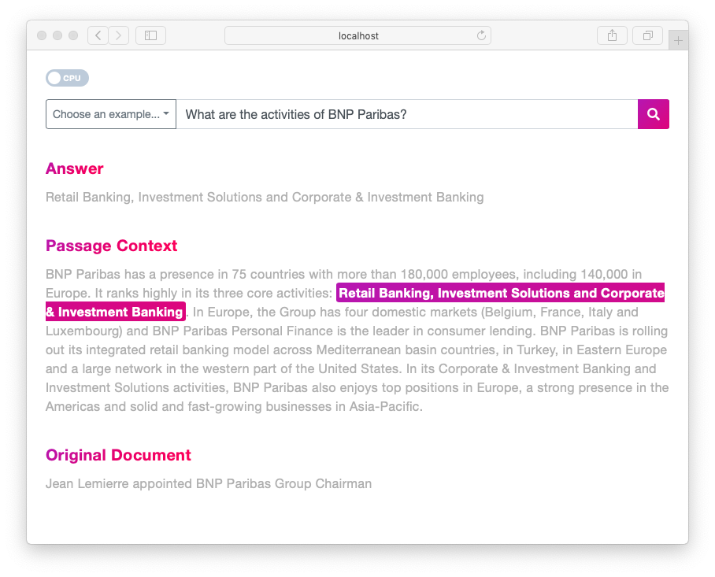

(Source:<https://towardsdatascience.com/how-to-create-your-own-question-answering-system-easily-with-python-2ef8abc8eb5>)

2. Introduction

**Information Retrieval(IR) System:** An Information Retrieval System is a network of algorithms which facilitate the search of relevant data/documents as per user requirement. Applications of IR are Search Engine, Image Retrieval, Music Retrieval, News Search, Question Answering System(Our problem statement), etc.

**IR Overview and Techniques:**

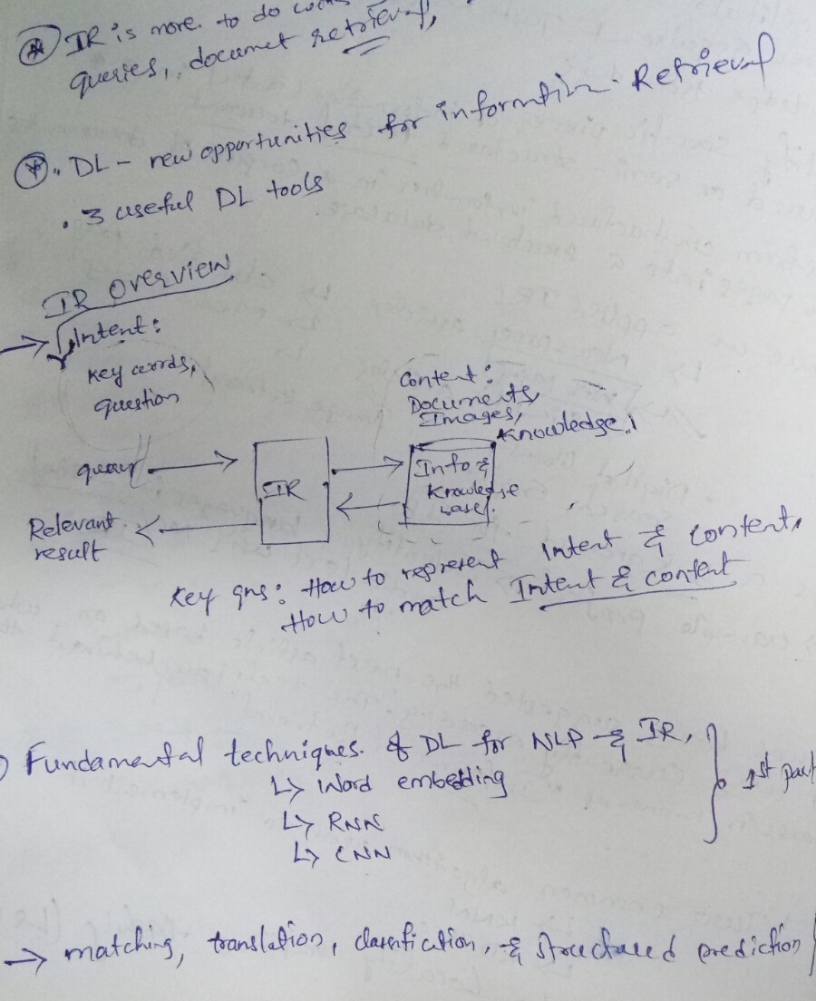

3. Document Retrieval

Traditional Approaches: Cosine Similarity and Euclidean Distance calculated between the tf-idf vectors of the query and each document.Is viewed as the matching (relevance) score between them.

4. Few Retrieval models are shown in below images

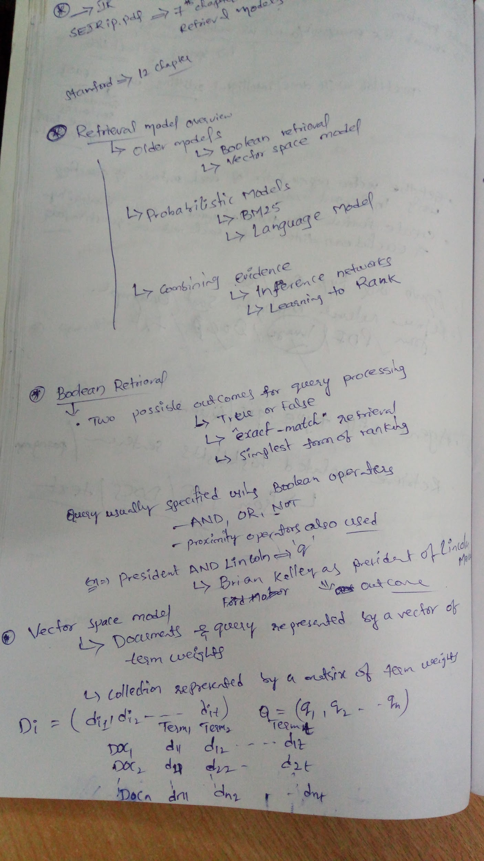

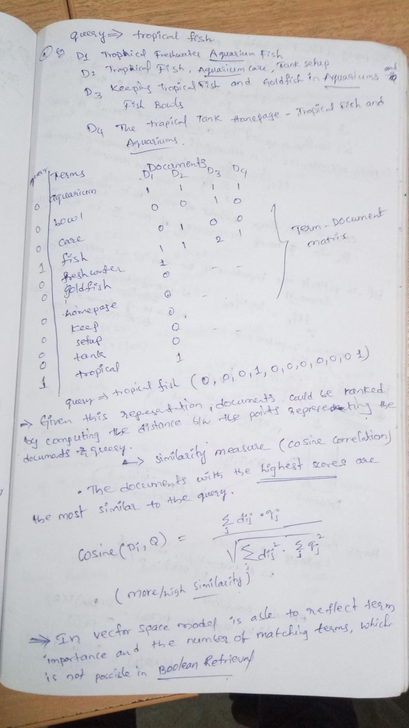

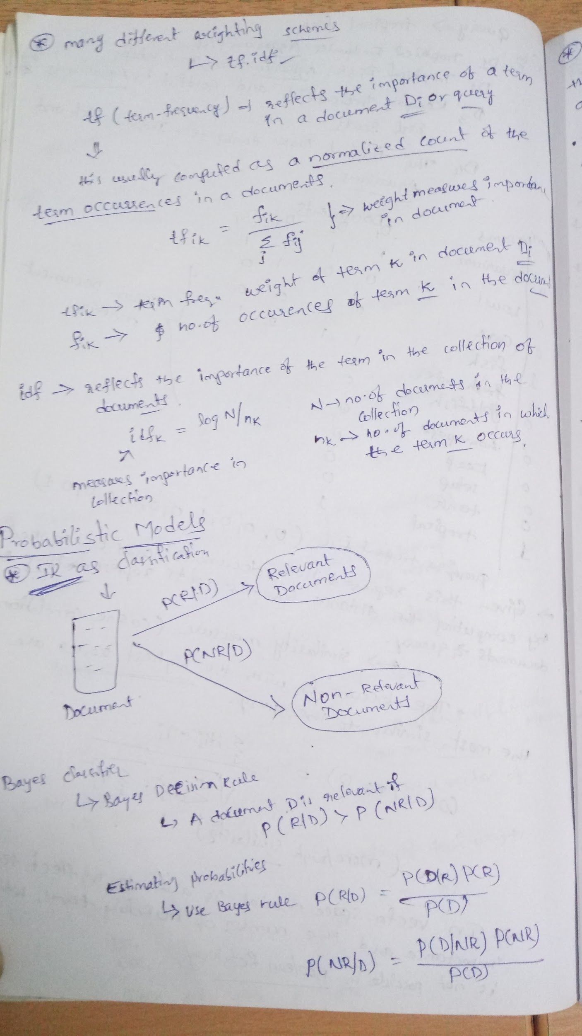

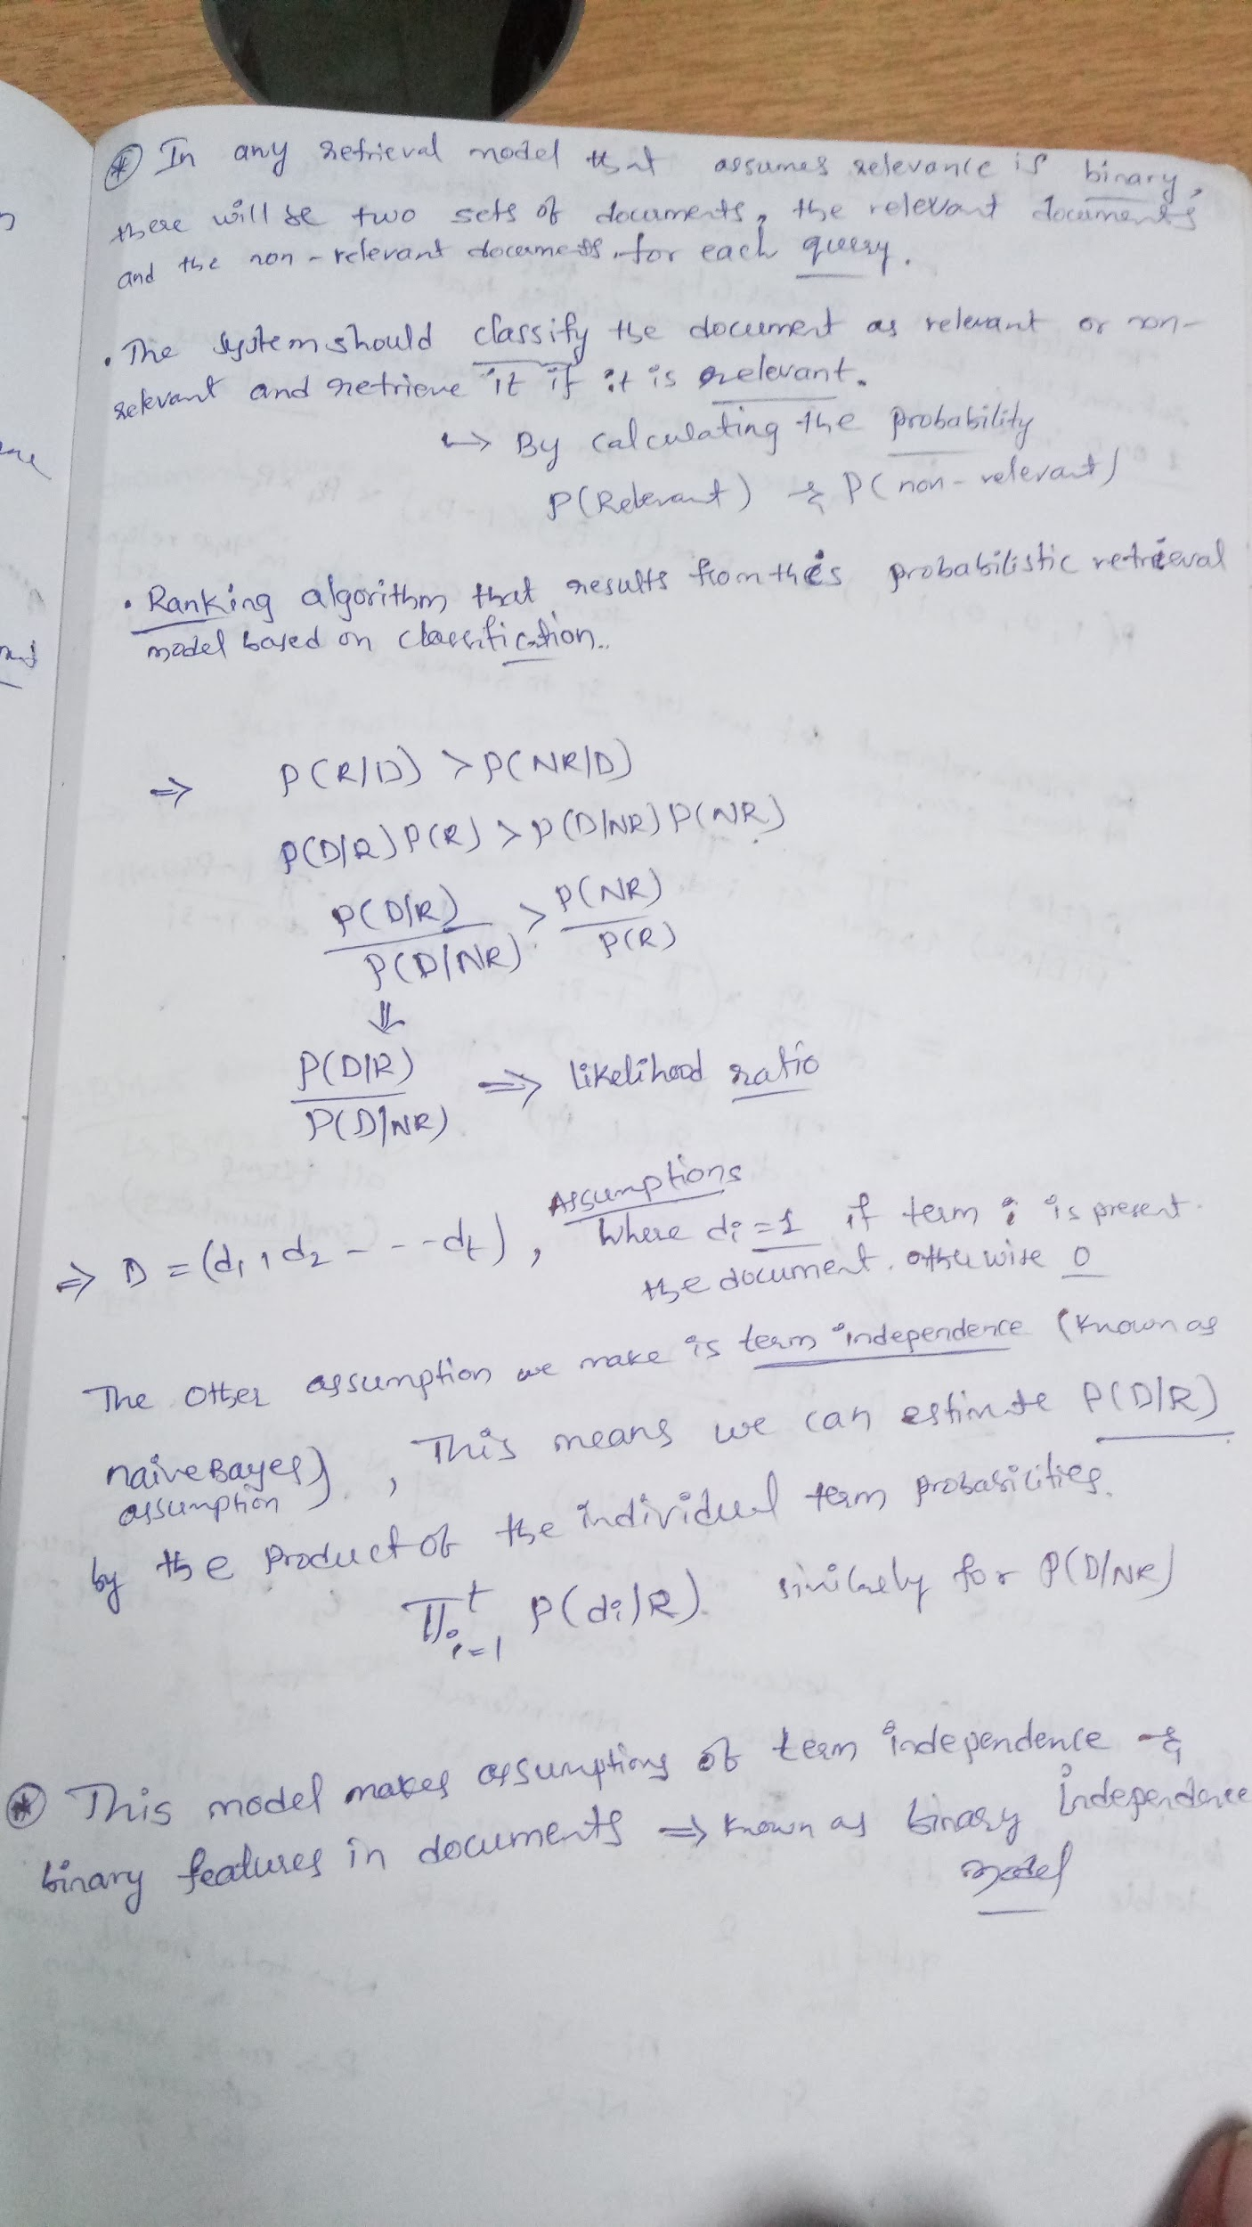

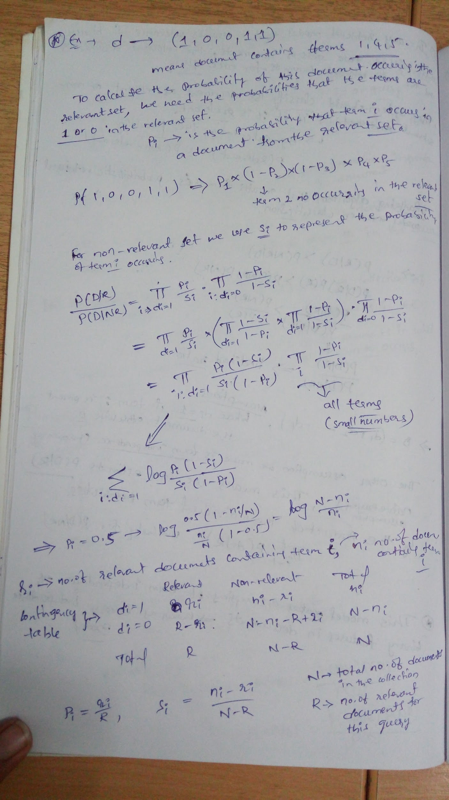

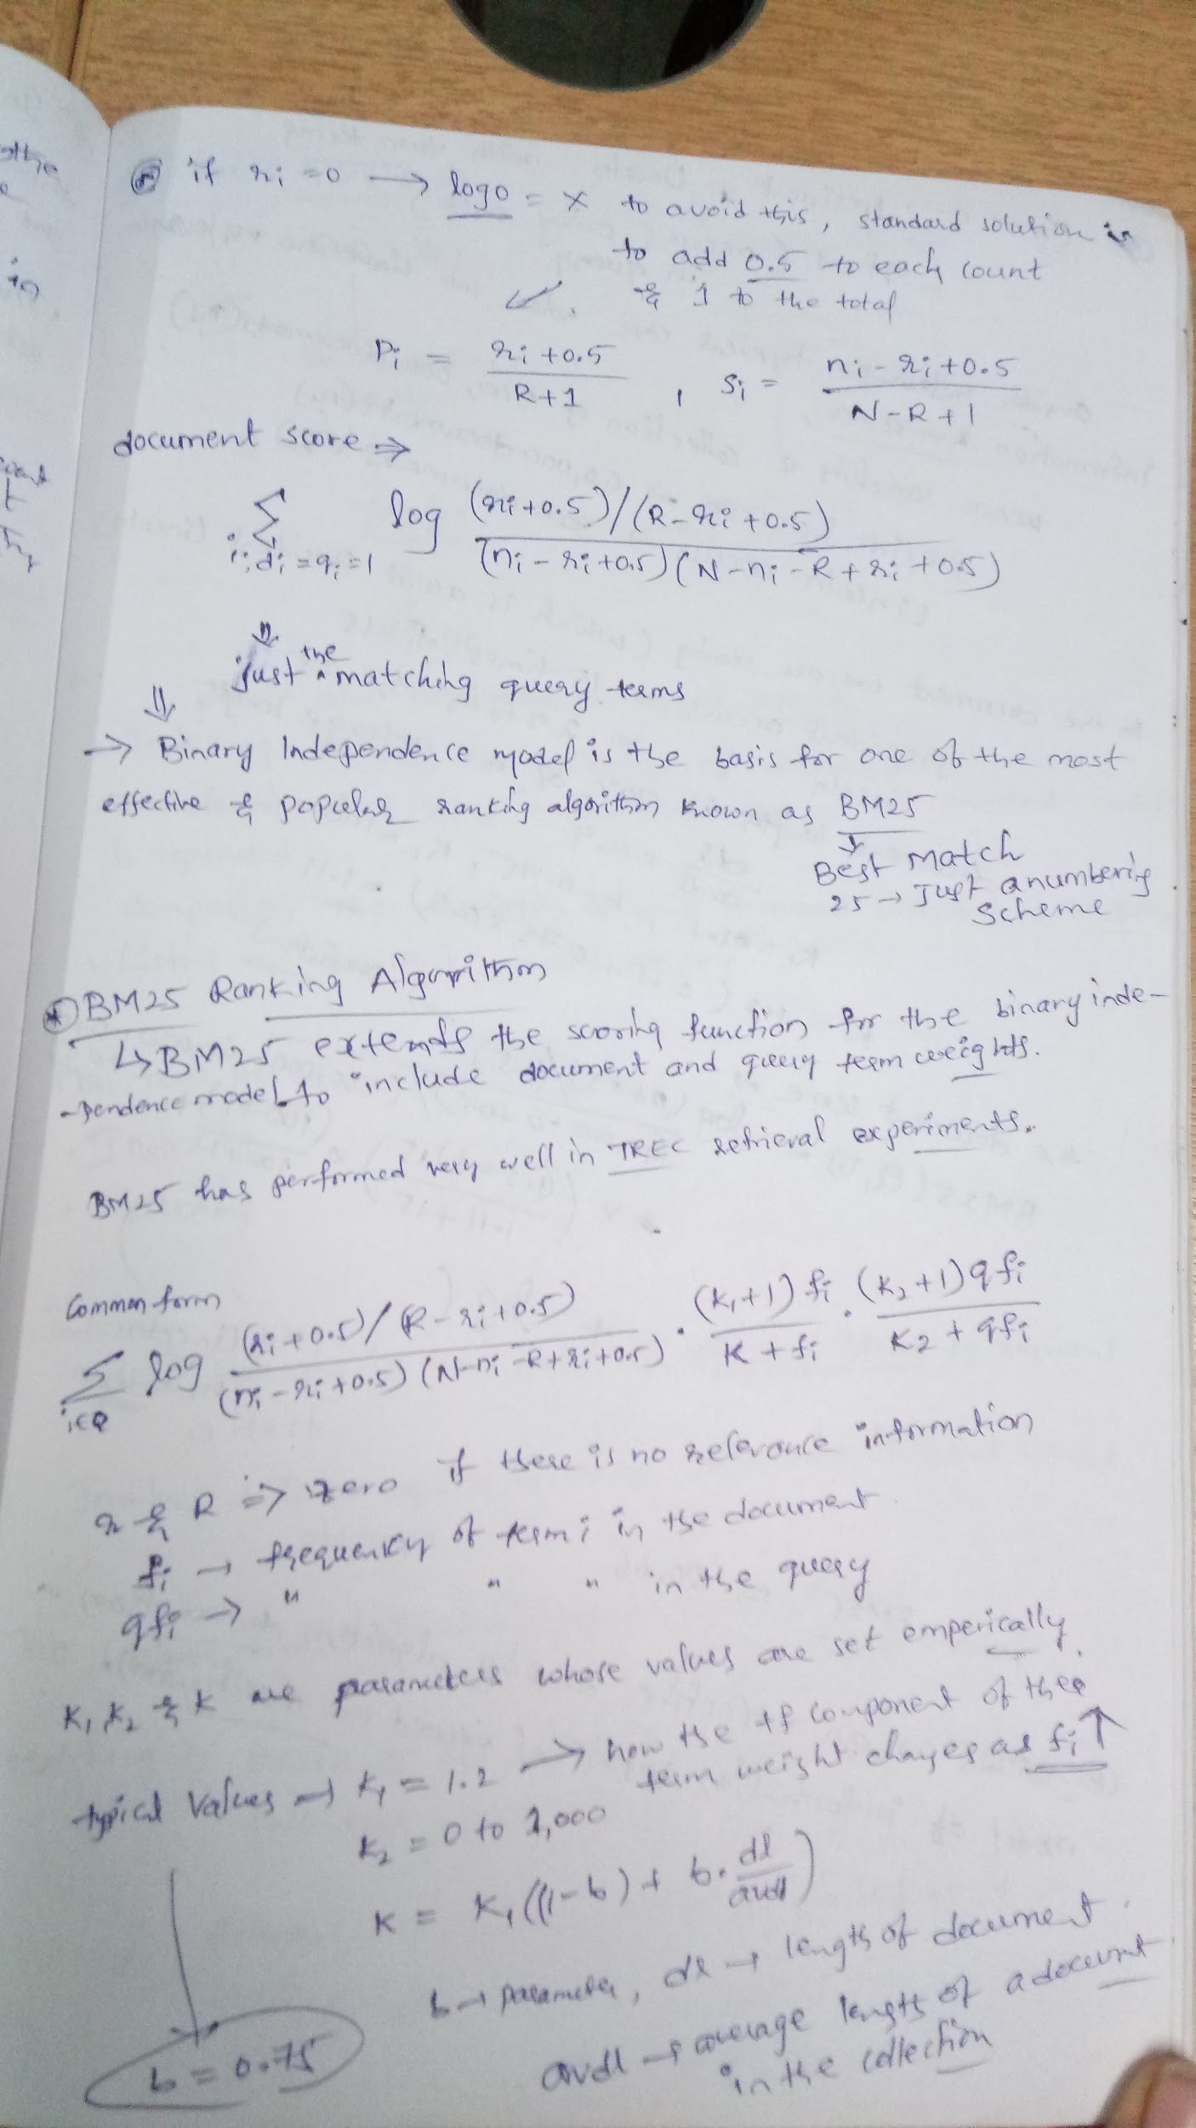

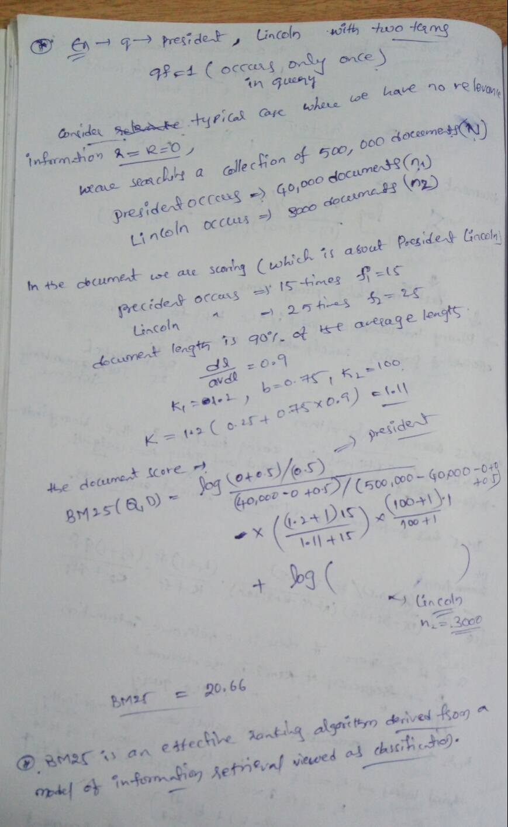

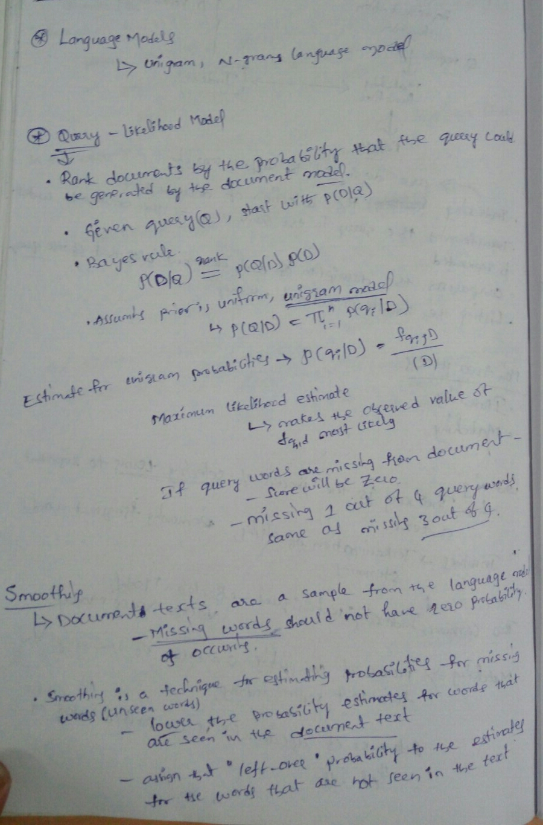

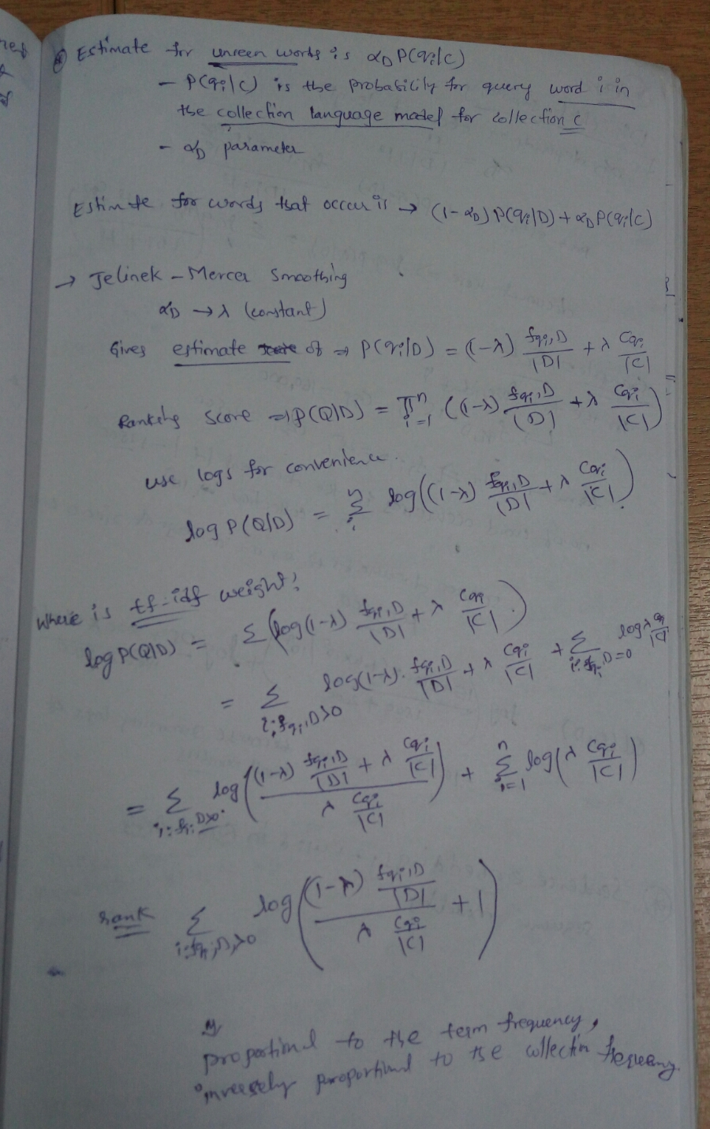

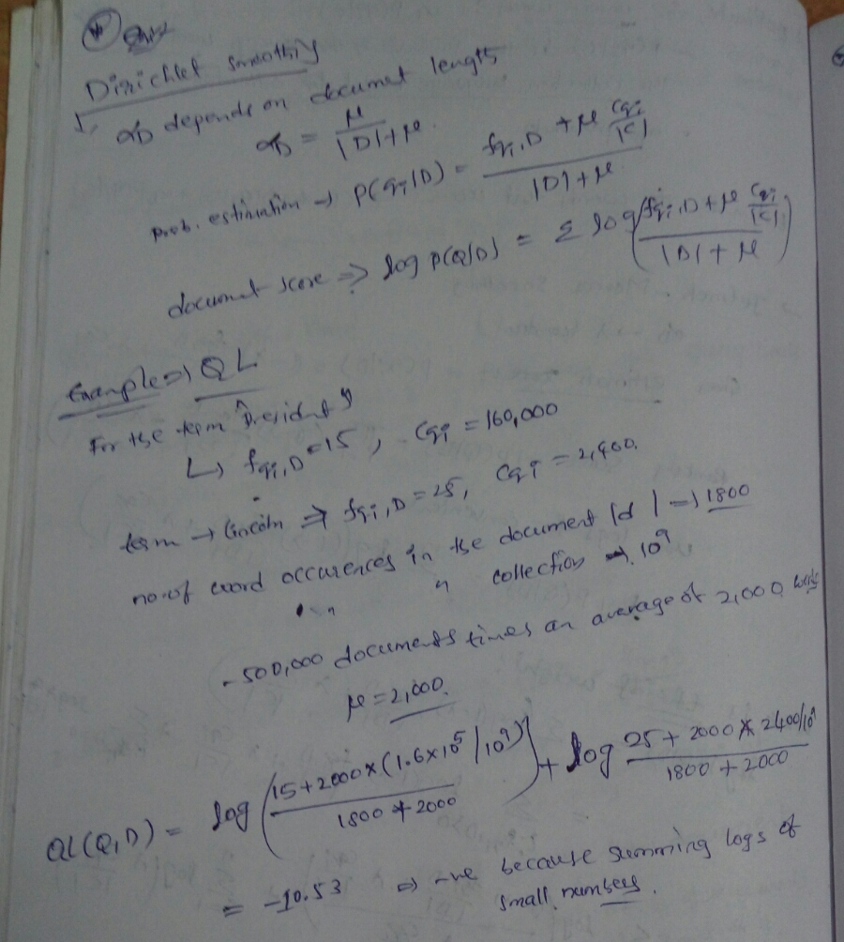

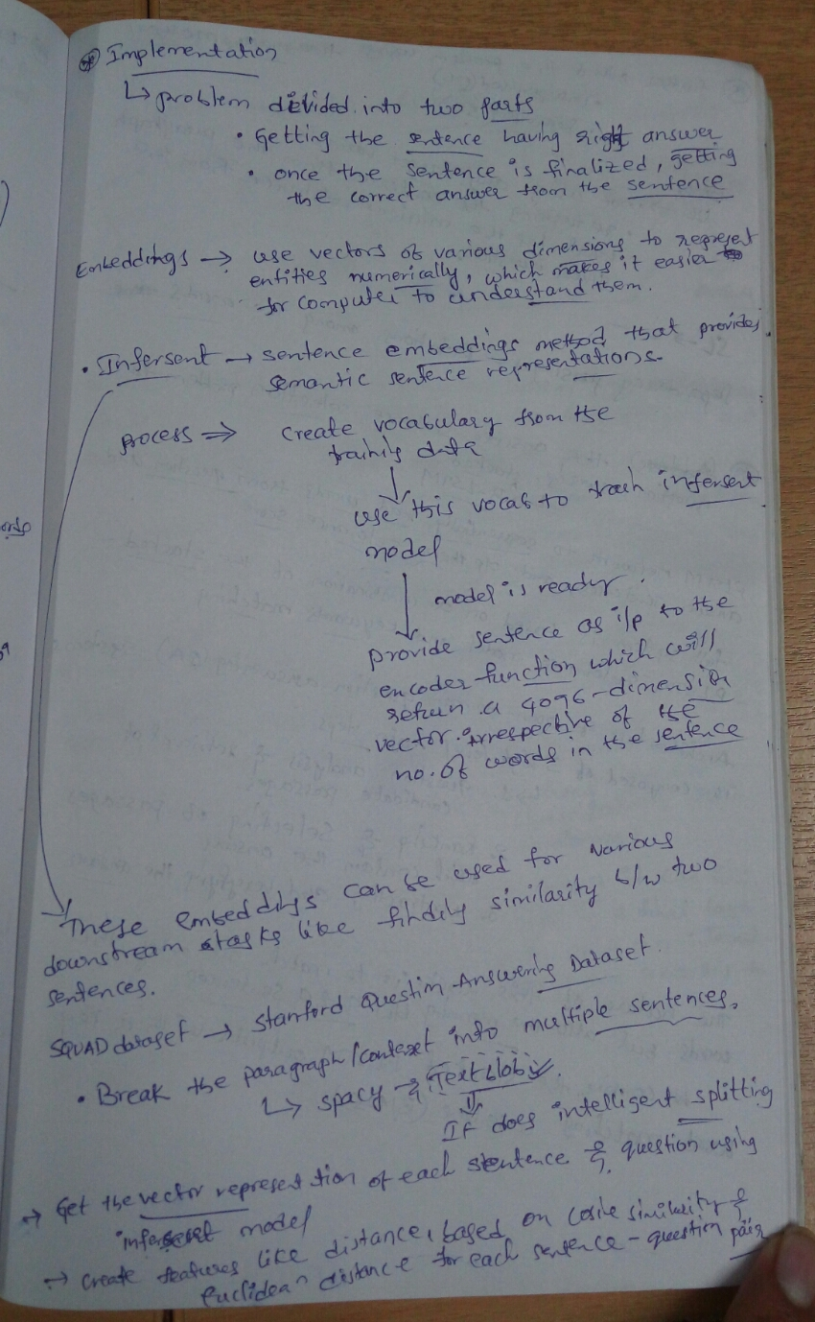

5. Research Papers:

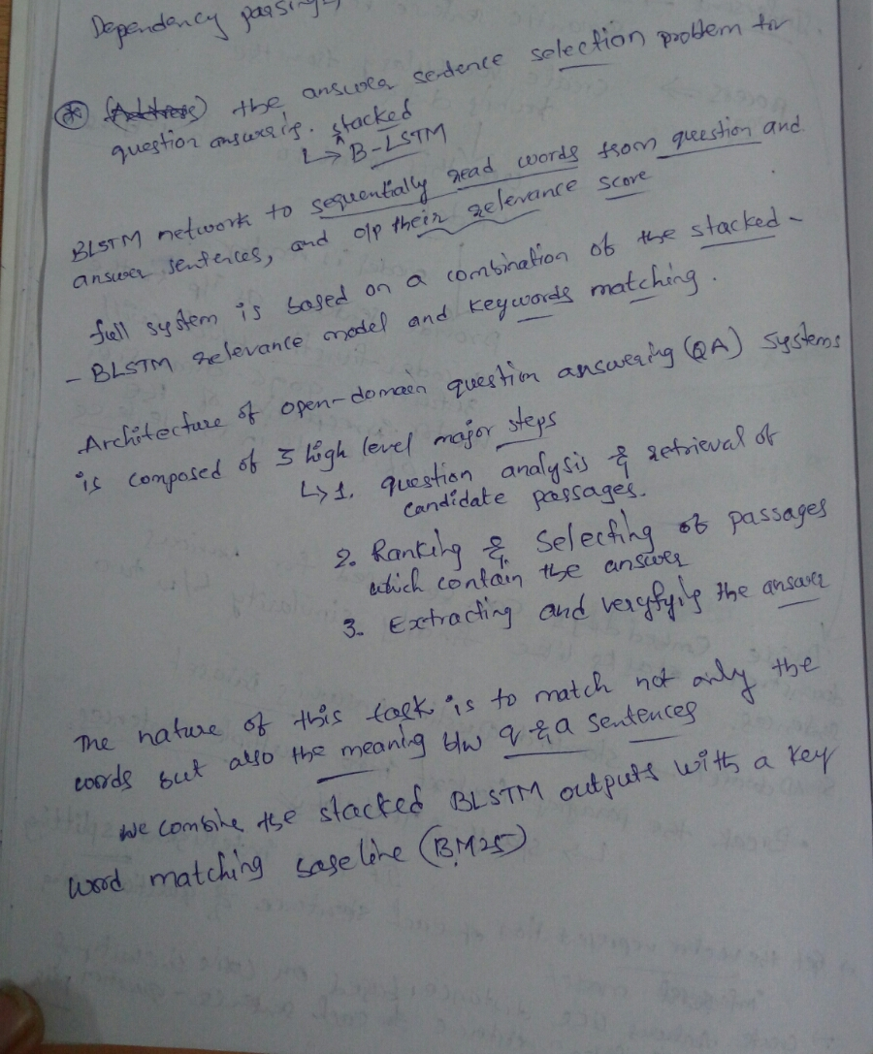

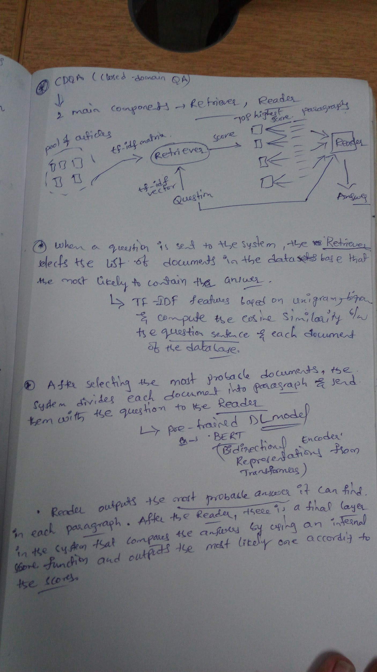

## **6. Question-Answer(QA) System**

## **Open-domain QA vs. closed-domain QA**

Two different kinds of QAsystems: **open-domain QA** (ODQA) systems and **closed-domain QA** (CDQA) systems.

Open-domain systems deal with questions about nearly anything, and can only rely on general ontologies and world knowledge. On the other hand, closed-domain systems deal with questions under a specific domain (for example, medicine or automotive maintenance), and can exploit domain-specific knowledge by using a model that is fitted to a unique-domain database.

CDQA System Architecture:

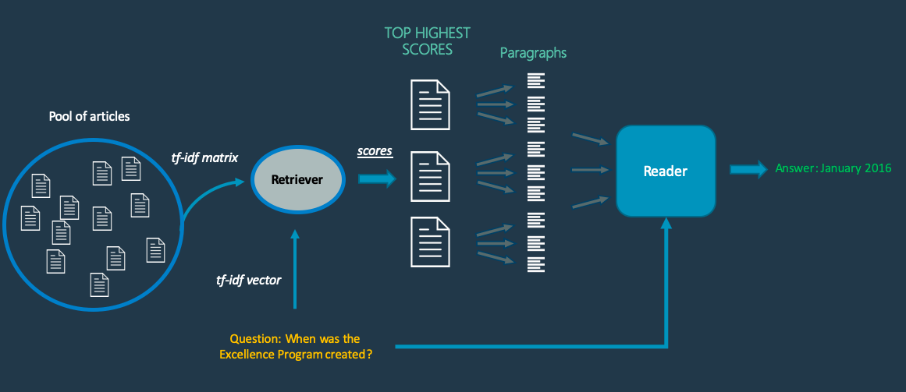

(Source:<https://towardsdatascience.com/how-to-create-your-own-question-answering-system-easily-with-python-2ef8abc8eb5>)

The cdQA architecture is based on two main components: the **Retriever** and the **Reader**. You can see below a schema of the system mechanism.

**Retriever:**

When a question is sent to the system, the **Retriever** selects a list of documents in the database that are the most likely to contain the answer, which creates TF-IDF features based on uni-grams and bi-grams and compute the cosine similarity between the question sentence and each document of the database.

**Reader:**

After selecting the most probable documents, the system divides each document into paragraphs and send them with the question to the Reader, which is basically a pre-trained Deep Learning model. The model used was the Pytorch version of the well known NLP model BERT, Then, the **Reader** outputs the most probable answer it can find in each paragraph. After the **Reader**, there is a final layer in the system that compares the answers by using an internal score function and outputs the most likely one according to the scores.

# 7. References

[1] <https://nlp.stanford.edu/IR-book/>

[2] <https://ciir.cs.umass.edu/downloads/SEIRiP.pdf>

[3]<http://www.search-engines-book.com/slides/>

[4]<https://www.hangli-hl.com/uploads/3/4/4/6/34465961/sigir_tutorial.pdf>

[5]<https://towardsdatascience.com/how-to-create-your-own-question-answering-system-easily-with-python-2ef8abc8eb5>